Diagram Errors:

* Each payment is associated with one account for company accounting purposes. Cardinality should be 1

Design Errors:

* Account has unique Identifier, thereby it should not be a weak entity.
* Each vehicle expense has a unique expense identifier, cardinality should be 1.
* Typically one payment is made per sale although multiple payments are sometimes made if a customer provides cash for part of the sale. Cardinality can be more.
* Vehicle characteristics do not require employees to sell it, it can exist on its own. Cardinality can be 0.
* Vehicle characteristics require it to be sold , it can exist on its own. Cardinality of payment can be 0 as payment need not be made immediately
* Account should have cardinality 1 in IncomeOf Relationship.
* Customers can just register but not buy any vehicle.

Corrected ERD is as follows:

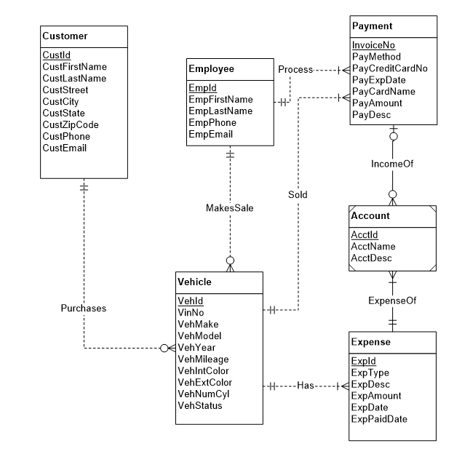

AcctID

AcctName

AcctDesc

Account